 | 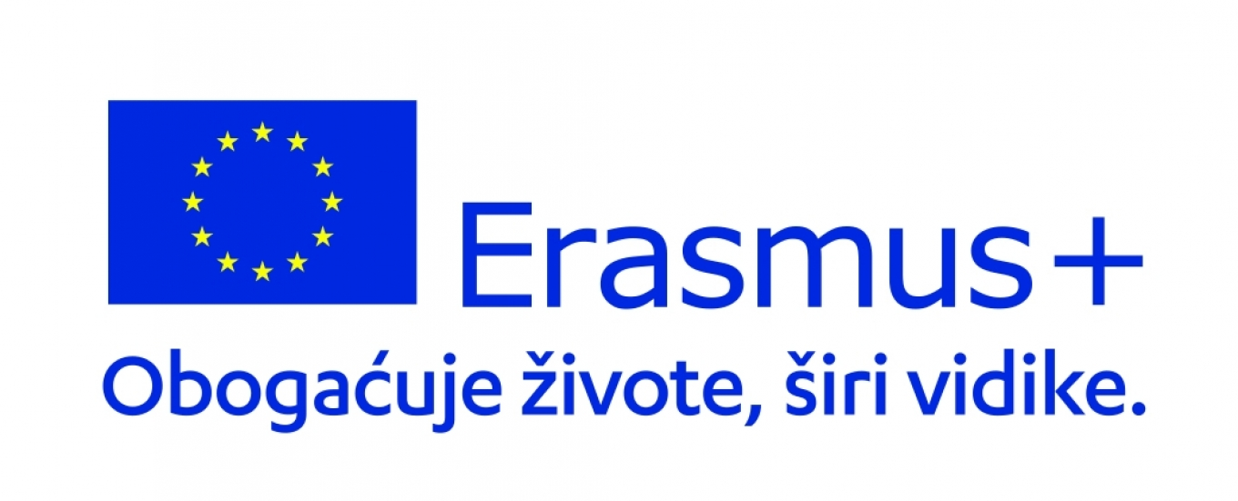

UNIVERSITY OF ZAGREB
Erasmus+ Information Sheet
University of Zagreb - General Information
Full Legal Name of Institution | Sveučilište u Zagrebu / University of Zagreb
Erasmus ID Code | HR ZAGREB01
Rector | Professor Stjepan Lakušić, PhD
Website | http://www.unizg.hr; http://www.unizg.hr/homepage/international-relations/
Head of Office | Branka Roščić (dr. phil.), head.international@unizg.hr, ☎️ 00385 1 46 98 101
Erasmus Institutional Coordinator | Renata Hranjec (Ms), erasmus.coordinator@unizg.hr, ☎️ 00385 1 46 98 128
Incoming Student Mobility (Erasmus+ KA131, bilateral exchange) | Bernard Špoljarić (Mr), incoming@unizg.hr, ☎️ 00385 1 46 98 165
Erasmus+ partner countries coordinator (KA171) | Željka Pitner (Ms), zeljka.pitner@unizg.hr; erasmus.noneu@unizg.hr, ☎️ 00385 1 46 98 105
Erasmus Outgoing Student Mobility (KA131) | Maja Grđan (Ms), erasmus-student-sms@unizg.hr, ☎️ 00385 1 46 98 106  Ivana Matijašević (Ms), erasmus-outgoing@unizg.hr, ☎️ 00385 1 46 98 126
Outgoing Erasmus Placements (KA131) | Ružica Bruvo (Ms), placement@unizg.hr, ☎️ 00385 1 46 98 107  Bojan Richter (Mr), praksa@unizg.hr ☎️ 00385 1 45 64 130
Erasmus Staff Mobility (KA131) | Emina Lehkec (Ms), staff@unizg.hr, ☎️ 00385 1 46 98 102
Erasmus+ agreements coordination (KA131) | Ratimira Šimundić (Ms), erasmus.sporazum@unizg.hr, ☎️ 00385 1 46 98 132
Erasmus+ BIP programmes (KA131) | Valentina Vajdić Cimperšak (Ms), erasmus.bip@unizg.hr, ☎️ 00385 1 46 98 116
Erasmus + inter-institutional agreements for programme countries
Erasmus+ inter- institutional agreements for programme countries | Erasmus+ inter-institutional agreements are signed by the Faculty/Academy Deans. The list of Faculties and Academies: www.unizg.hr/homepage/about-university/constituent-units/organizational-units/  All the Erasmus+ inter-institutional agreements are signed 1 year in advance for the next academic year. Deadline: 1 November http://www.unizg.hr/homepage/international-relations/partnerships/erasmus/

The sending institution, following agreement with the University of Zagreb, is responsible for providing support to its nominated candidates so that they can have the recommended language skills at the start of the study or teaching period:

Recommended language skills*
Receiving institution [Erasmus code] | Language  of instruction 1 | Language  of instruction 2 | Recommended language of instruction level
 |  |  | Student Mobility for Studies | Staff Mobility for Teaching
HR ZAGREB 01 | Croatian | English | B2 (obligatory) | B2
*For more details on the language of instruction see the course catalogue.

Additional requirements
In case of additional requirements in regard to academic, organisational or other aspects (e.g. students with special needs) please contact the International Office: incoming@unizg.hr.

Calendar
Home university nominates students via form available on our Web page:
Receiving institution [Erasmus code] | Winter term  (October 1 to February 28/29) | Summer term (March 1 to June 30)
HR ZAGREB 01 | 1 May | 1 November
All students need to apply through the application link by the following date:
Receiving institution [Erasmus code] | Winter term  (October 1 to February 28/29) | Summer term (March 1 to June 30)
HR ZAGREB 01 | 15 May | 15 November
2. The University of Zagreb will send its decision within 5 weeks.
3. A Transcript of Records will be issued by the faculty/academy of the University of Zagreb no later than 5 weeks after the assessment period has finished at the receiving faculty/academy.
4. Termination of the agreement

In the event of unilateral termination, a notice of at least one academic year should be given. This means that a unilateral decision to discontinue the exchanges notified to the other party by 1 September 20XX will only take effect as of 1 September 20XX+1. The termination clauses must include the following disclaimer: "Neither the European Commission nor the National Agencies can be held responsible in case of a conflict."

Information
Grading systems of the University:
www.unizg.hr/homepage/study-at-the-university-of-zagreb/academic-information/the-ects-system-and-student-progress-assessment/
Visa
The sending and receiving institutions will provide assistance, when required, in securing visas for incoming and outbound mobile participants, according to the requirements of the Erasmus Charter for Higher Education.
Information and assistance can be provided by the following contact points and information sources:
Institution [Erasmus code] | Contact details (email, phone) | Website for information
HR ZAGREB01 | incoming@unizg.hr, 00385 (0)1 4698 165 | http://www.unizg.hr/homepage/international-exchange/exchange-students/before-coming-to-zagreb/
Insurance
The sending and receiving institutions will provide assistance in obtaining insurance for incoming and outbound mobile participants, according to the requirements of the Erasmus Charter for Higher Education.
For mobile participants at the University of Zagreb insurance cover is not automatically provided. Information and assistance can be provided by the following contact points and information sources:
Institution [Erasmus code] | Contact details (email, phone) | Website for informati0on
HR ZAGREB01 | incoming@unizg.hr , 00385 (0)1 4698 165 | www.unizg.hr/homepage/international-exchange/exchange-students/before-coming-to-zagreb/
Housing
The receiving institution will guide incoming mobile participants in finding accommodation, according to the requirements of the Erasmus Charter for Higher Education.
Information and assistance can be provided by the following persons and information sources:
Institution [Erasmus code] | Contact details (email, phone) |  | Website for information
HR ZAGREB01 | Petra.Sarenic@sczg.hr |  | www.unizg.hr/homepage/international-exchange/exchange-students/student-services/housing/

Student Exchange information
Nominations  &  Application Procedure | Nominations - Home university nominates students via a form available on our web page.  Application must be done through the Central IRO office. Application form (ON-LINE application) and other supporting documents are available at: http://www.unizg.hr/homepage/international-exchange/exchange-students/how-to-apply/  Courses/programs in Croatian  http://www.unizg.hr/homepage/study-at-the-university-of-zagreb/degrees-studies-and-courses/studies-and-courses-in-croatian/  Courses/programs in English  http://www.unizg.hr/homepage/study-at-the-university-of-zagreb/degrees-studies-and-courses/studies-and-courses-in-english/  APPLICATION DEADLINES  - 15 May - winter (1st) semester / academic year (starting in October)  - 15 November - summer (2nd) semester (starting in March)  ! Students that require a VISA are strongly advised to apply and send their documents one month prior to the deadline since the Visa application process may take several weeks or even months.
Areas of study / courses | Students are allowed to enrol in programs / courses offered by UNIZG faculties/academies, respecting their specific requirements (course pre-requisites, areas of study arranged through institutional agreements with UNIZG etc.).
Croatian  Language Course | http://www.unizg.hr/homepage/learn-croatian/
Course registration | Exchange students enrol upon their arrival in Zagreb (not before) at the UNIZG faculty/academy they will attend.
Transcript of records - availability | Official transcripts must be requested by the student personally at the student office of the respective faculty / academy at the end of the exchange period, prior to departure.

