UNIVERSITY OF BELGRADE – MOBILITY FACT SHEET 2023
Key Data on the Institution
Name of the University | University of Belgrade
Head of Institution | Prof. Dr Vladan Djokic, Rector
Address | Studentski trg 1, 11000 Belgrade
Erasmus + Coordinator | Prof. Dr Ratko Ristic, Vice-Rector for International Relations
General Website | www.bg.ac.rs
Incoming mobility | https://mobion.bg.ac.rs/erasmus+/erasmus-pages/incoming-candidates/incoming-about-this-section
Email | kabinet@rect.bg.ac.rs

Erasmus+ Information
Erasmus + Coordinator | Prof. Dr Ratko Ristic, Vice-Rector for International Relations
ECTS Coordinators at UB faculties and institutes | https://mobion.bg.ac.rs/erasmus+/ects-coordinators-contacts
RS Erasmus Agency | https://erasmusplus.rs/home-eng/
UB Erasmus Charter | shorturl.at/xzST0
International Relations Office | https://mobion.bg.ac.rs/erasmus+/contact
UB Online Mobility Platform | https://mobion.bg.ac.rs
Required documents & Nomination procedure for incoming candidates: | https://mobion.bg.ac.rs/erasmus+/erasmus-pages/incoming-candidates/nomination-procedure  https://mobion.bg.ac.rs/erasmus+/erasmus-pages/incoming-candidates/incoming-required-documents

Academic Calendar (lecture periods)
 | Lecture periods
First term (winter term) | October 1st | January 15th
Exam period | Mid-January – Mid February
Second term (summer term) | February 17th | May 31st
Exam period | June 1st – June 30th

Admission and registration

Exchange students (credit transfer, non-degree seeking)
At the moment of the application and during the entire stay abroad, the students must be enrolled in an undergraduate or graduate program at their home institution and pay the corresponding tuition fees there, where applicable.

A learning and recognition agreement is mandatory and has to be submitted to the home and host institutions before the start of the stay abroad. Modifications are possible at the beginning of each semester.

Additional requirements
All students and staff coming to the University of Belgrade (RS BELGRAD02) are required to register through the online application system at: http://mobion.bg.ac.rs/ by the dates specified in the Academic Calendar section.

All Erasmus+ KA1 mobility nominations from the University of Belgrade (RS BELGRAD02) must be sent exclusively from the International Relations Office of the UB, duly signed by the Rector, or Vice-Rectors. Those applications and nominations sent directly to host universities by candidates or other Faculties/Institutes of the University of Belgrade should not be accepted and International Relations Office of the University of Belgrade should be informed about it. Please note that the applications received through the above manner will not be financially supported.

Please send the Nomination list to the designated UB IRO coordinator, in accordance to the deadline below.
International Relations coordinators: https://bg.ac.rs/en/international/contacts.php

Students  and  Staff | Nomination deadline  (with official Nomination letter sent by the Partner institution to UB) | For the Semester 1 (Winter term) and full academic year: April 15  For the Semester 2 (Summer term): October 25  ERASMUS+ Exchange program
 | Application deadline  at Mobion  http://mobion.bg.ac.rs | Online for Erasmus+ applicants at Mobion  http://mobion.bg.ac.rs:  For the Semester 1 (Autumn semester) and for the full academic year: May 15  For the Semester 2 (Spring semester): November 25  Application documents are uploaded to the Mobion platform: http://mobion.bg.ac.rs according to the above-mentioned Registration deadlines.  For Students:  - Diploma and diploma supplement of previously obtained degrees;  - Transcript of Records in the English language;  - Proof of language skills of relevant language at the host institution (such as copies of course certificates, language tests etc.);  - CV in the English or the Serbian language;  - Letter of Motivation in the English or the Serbian language;  - Passport number; date of issuance; date of validity (passport copy)  - Erasmus+ Learning Agreement: Signed by the relevant authority at the home institution  - Photo;  - Invitation letter for PhD students from the mentor of the Host institution/faculty  For Staff for teaching and Staff for training:  - Erasmus+ Mobility Agreement ( Teaching / Training ): Signed by the relevant authority at the home institution;  - CV in the English or the Serbian language;  - Invitation letter from the Host faculty/institute in Belgrade;  - Passport number; date of issuance; date of validity;  - Photo;
 | Contact information | kostrm@rect.bg.ac.rs
Course information websites
Study programs | https://mobion.bg.ac.rs/erasmus+/erasmus-pages/incoming-candidates/ub-academic-offer  https://www.bg.ac.rs/study-programs/

Language requirements
Language of instruction A: | Language | Serbian
Please check at the appropriate Faculty at the University of Belgrade about the required Language of instruction for each study program. | Required level | B1/B2 for students
 | Accepted certificate (s)  Not required for candidates from: Croatia, Bosnia & Herzegovina, Montenegro, North Macedonia | Official language certificate issued by an official language school. Or official confirmation from the sending University.
Language of instruction B: | Language | English
Please check at the appropriate Faculty at the University of Belgrade about the required Language of instruction for each study program. | Required level | B1/B2 for students  C1 for staff
 | Accepted certificate (s) | Official language certificate issued by an official language school or any other official Authority. Or official confirmation from the sending University.

Student and welcoming services
Accommodation | Accommodation at the Student dormitories in Belgrade is not granted for Erasmus+ students.  Private accommodation with (with no charge for agency):  www.cityexpert.rs/en  http://studyinserbia.blogspot.com/2013/07/student-accommodation-in-serbia_8.html  https://www.4zida.rs/izdavanje-stanova  https://roommateor.com/izdavanje-stanova/beograd  https://izdavanjestanova-beograd.rs/  Only Staff can apply directly at the following Guest house:  Guest house “Kralj Aleksandar I”  https://www.sc.rs/usluge/hosteli  Address: Bulevar kralja Aleksandra 75, 11000 Belgrade  Phone:+381 11 401 800 or :+381 11 3400 693  Reservations on: konakkraljaleksandar@gmail.com  Transportation: Tram: 2, 5, 6, 7, 12 or 14  Bus: 25, 26, 27, 27l, 32, 65 or 74
Facilities for students with special needs | Persons with disabilities are asked to visit the following link:  http://www.bg.ac.rs/en/members/centers/students-with-disabilities.php
Welcome event / orientation week | Orientation days are organized at the beginning of each semester. OD include a reception of International Students by International Office Staff and Erasmus Student Network representatives (http://belupgrade.esn.rs/). ESN will provide a Buddy for students to help him/her in the first days of their stay in Belgrade.
Language Course(s) | http://learnserbian.fil.bg.ac.rs  Mandatory registration till Mid-January or Mid-September:  http://learnserbian.fil.bg.ac.rs/admissions.php  Students who attend Serbian language course as part of their exchange program at the University of Belgrade and want to transfer credits to their home university must register for the course and the exam on E-student platform of our faculty. They are doing it by sending an email to: mobilnost@fil.bg.ac.rs and mobility@fil.bg.ac.rs  Fall semester: Registration till October 01  Spring semester: Registration till February 18  Free of charge for Erasmus+ candidates!
Health Insurance | Foreign citizens exercise their right to urgent medical care based on certain forms (if such have been prescribed), European Health Insurance Card (EHIC) or on the basis of a specific health insurance document or another international health insurance policy proving valid insurance coverage at the territory of the Republic of Serbia for the whole period of stay.  Urgent medical care for domestic and international students in Belgrade:  Student Polyclinic  Krunska 57, 11000 Belgrade,  Phone: 011 / 2430-814, 2433-488, 2436-434, 3440-939
Visa/  Residence Permit | Please be so kind and read before your arrival about the Rights and Obligations of foreign citizens in Serbia:  Information about Residence permit procedure for foreigners in Serbia:  http://www.mup.gov.rs/wps/portal/en/information  International students can enter Serbia with a valid passport and need to submit a Residence permit application (you are not a tourist, you are a foreign student) at the Police Department for foreign citizens, Omladinskih brigada 1, Novi Beograd, SIV 3 building.  The first mandatory obligation after arrival at the territory of the Republic of Serbia is to register within 24 hours at the nearest Police station in Belgrade together with the landlord of the rented apartment where you will get the Confirmation of Registration.  In case the student is staying in a student dormitory, the student dormitory will take over the obligation of registration at the nearest Police station.  The Residence permit costs in Belgrade are according to the last check about 18.000,00 RSD (approximately 140 Euro) for a stay up to 6 months.  Please provide your CV in the Serbian language since the Police Department for foreign citizens in Belgrade is asking for it when you are applying for the Residence permit.  Please provide a Certificate from your home university stated you got a stipend during the stay in Serbia, or credit card or foreign currency account statement. The Police is asking for proof of sufficient financial means during your stay in Serbia.  Please provide the Health Insurance Policy with Covid for your stay in Belgrade (EU and Non-EU students should provide this Health insurance Policy).  Please provide the Confirmation of Registration (White card you got after registration within 24 hours) and the Certificate on Enrollment at the appropriate Faculty.  In general, the following mandatory documentation for temporary residence approval (on every grounds):  • a valid personal or official passport  • proof of means of subsistence during the planned temporary residence  • registration of either short-term or residential address in the Republic of Serbia  • proof of health insurance during the planned residence  • two photos (35x45mm, color, full face)  • filled out application form  • proof of prescribed administrative fee payment  International staff residing up to 90 days do not need a Visa/Residence permit unless they are hired on the basis of an employment contract.
Transportation Card BusPlus | Belgrade Plus City Transportation Company  https://bgnaplata.rs/  E-mail: info@bgnaplata.rs  Zone A, B and C  Students should buy tickets for Zone A.  Documents required at Belgrade Plus Points of sale:  - Certificate from the Faculty in Belgrade  - Student booklet issued at the Faculty in Belgrade  - Passport  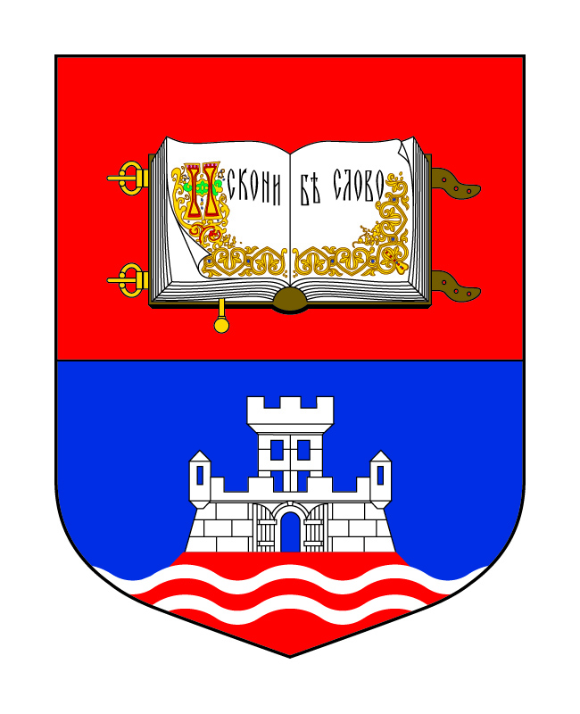  BELGRADE PLUS Points of sale:  No. Address Working hours Saturday  Skender Begova 47 07:00-19:00 08:00-15:00  Trg Republike Shopping Mall 07:00-19:00 08:00-14:00  Deligradska 10 07:00-19:00 08:00-14:00  Bulevar Mihajla Pupina 167 07:00-19:00 08:00-14:00  Knez Mihailova 6, second floor 07:00-20:00 08:00-14:00  Price for the Student transportation Card for one months (for students up to 26 years):  1.000 RSD  Price for the Student transportation Card for one months (for students over 26 years old):  2.200 RSD  Students need to buy every months at the Points of sale their ticket.
Student Cafeteria Card (Mensa Card) | After arrival in Serbia/Belgrade international candidates will be supplied with detailed information and document for the Student Cafeteria card at the International Relations Office of the University of Belgrade, (Rectorate Building), Studentski trg 1, 11000 Belgrade, Serbia, first floor, Office No. 23.  The Student Cafeteria Card for students should be obtained at the following address:  Student Center  Svetozara Markovica No. 56,  11000 Belgrade  Phone: +381 11 363-7299
Buddy support | Belgrade ESN network  Assistance to foreign students in Belgrade.  This network can provide a buddy for helping students during their stay in Belgrade and make their start easier and less stressful.  www.belupgrade.esn.rs  office.belupgrade@esn.rs
Useful Websites  for your social and cultural life in Serbia | Belgrade Guide In Your Pocket: http://www.inyourpocket.com/data/download/belgrade.pdf  Tourist Organization of Belgrade:  https://www.tob.rs/en  Tourist Organization of Serbia:  http://www.srbija.travel/en
 | Enclosed you will also find the GENERAL INFORMATION SHEET with necessary information about administrative obligations you have to perform in Belgrade, like photos, CV, various charges etc. for the official Authorities in Belgrade when obtaining Residence Permit, Transportation and Mensa Card.

International Office / Student Service Center / Visitors’ Service

Mailing address | Studentski trg 1, 11000 Belgrade, Serbia
Phone | +381 11 3207453
Website/ email | http://bg.ac.rs/en/international/contacts.php  https://www.bg.ac.rs/vodic-za-studente/  (only in the Serbian language_
Working hours with students and staff | Every Working day 10.00 – 13.00  First floor, Office No. 23
Student and Staff Exchange | Incoming | Marina Kostrica  kostrm@rect.bg.ac.rs
 | Outgoing

